**DL EXPERIMENT 1**

**AND GATE:**

**Python code:**def step(x):

return 1 if x >= 0 else 0

def check_AND(w1, w2, b):

AND_truth = {

(0, 0): 0,

(0, 1): 0,

(1, 0): 0,

(1, 1): 1

}

for (x1, x2), expected in AND_truth.items():

output = step(x1 * w1 + x2 * w2 + b)

if output != expected:

return False

return True

w1 = float(input("Enter w1: "))

w2 = float(input("Enter w2: "))

b = float(input("Enter bias b: "))

if check_AND(w1, w2, b):

print("These weights and bias CAN form an AND gate.")

else:

print("These weights and bias CANNOT form an AND gate.")

**Output:  
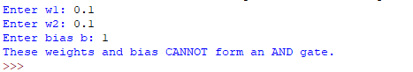**

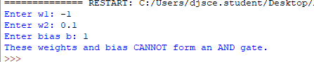

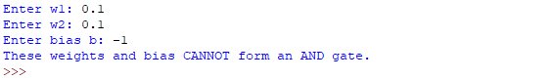

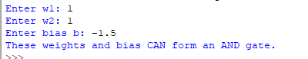

**ARCHITECTURE:  
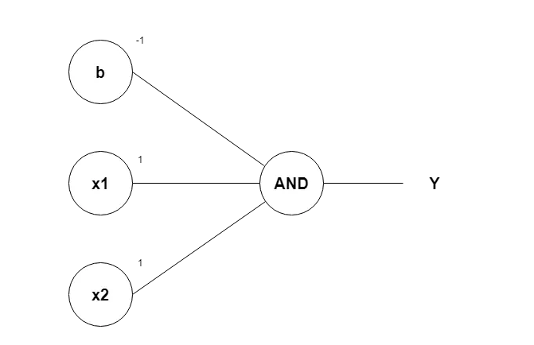**

**OR GATE:**

**CODE:**def step(x):

return 1 if x >= 0 else 0

def check_OR(w1, w2, b):

AND_truth = {

(0, 0): 0,

(0, 1): 1,

(1, 0): 1,

(1, 1): 1

}

for (x1, x2), expected in AND_truth.items():

output = step(x1 * w1 + x2 * w2 + b)

if output != expected:

return False

return True

w1 = float(input("Enter w1: "))

w2 = float(input("Enter w2: "))

b = float(input("Enter bias b: "))

if check_OR(w1, w2, b):

print("These weights and bias CAN form an OR gate.")

else:

print("These weights and bias CANNOT form an OR gate.")

**OUTPUT:  
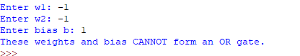**

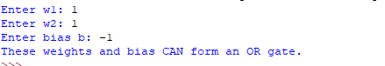

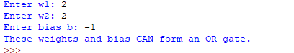

**ARCHITECTURE:  
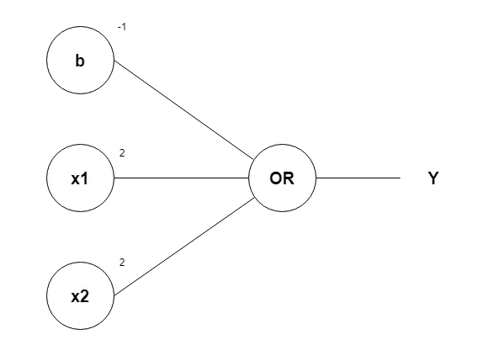**

**NOT GATE:**

def step(x):

return 1 if x >= 0 else 0

def check_NOT(w1, b):

NOT_truth = {

0: 1,

1: 0

}

for x, expected in NOT_truth.items():

output = step(x * w1 + b)

if output != expected:

return False

return True

w1 = float(input("Enter w1: "))

b = float(input("Enter bias b: "))

if check_NOT(w1, b):

print("These weights and bias CAN form a NOT gate.")

else:

print("These weights and bias CANNOT form a NOT gate.")

**OUTPUT:  
**

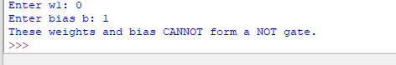

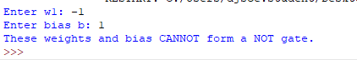



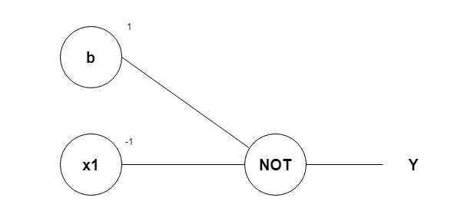

**XOR GATE:  
CODE:**def step(x):

return 1 if x >= 0 else 0

def perceptron(x1, x2, w1, w2, b):

return step(x1*w1 + x2*w2 + b)

def perceptron_not(x, w, b):

return step(x*w + b)

def check_final_layer_XOR(w1_final, w2_final, b_final):

w1_and, w2_and, b_and = 0.5, 0.5, -0.7

w1_or, w2_or, b_or = 0.5, 0.5, -0.2

w_not, b_not = -1, 0.5

XOR_truth = {

(0, 0): 0,

(0, 1): 1,

(1, 0): 1,

(1, 1): 0

}

for (x1, x2), expected in XOR_truth.items():

and_out = perceptron(x1, x2, w1_and, w2_and, b_and)

or_out = perceptron(x1, x2, w1_or, w2_or, b_or)

not_and_out = perceptron_not(and_out, w_not, b_not)

xor_out = perceptron(or_out, not_and_out, w1_final, w2_final, b_final)

if xor_out != expected:

return False

return True

print(check_final_layer_XOR(1, 1, -1.5))

**OUTPUT:  
**

**GIVING DIFFERENT WEIGTHS LETS SAY : -1, 1 AND BIAS AS 1 WE GET:  
**

**ARCHITECTURE:  
